Reading the Tea Leaves:
Canvas Analytics and Using Student Feedback to Inform Teaching

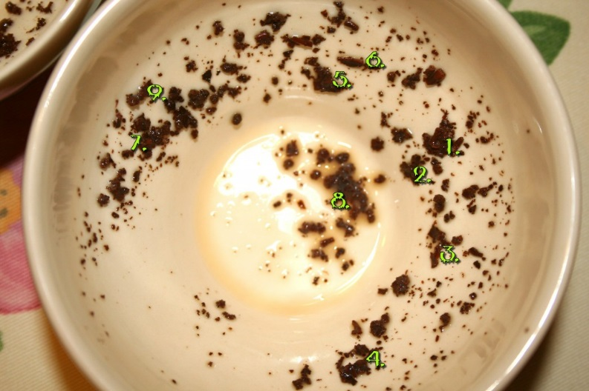
Retrieved from http://kimmikillzombie.killer-cosmetics.com/2010/09/adventures-in-tea-leaf-reading/
Can start by logging into Canvas and then going to a sandbox. Much of this will be watch…but we like to have you in the lab so that you have the context and so that you can
How to read Tea Leaves (Tasseomancy)
- Make a cup of tea from the finest leaves
- Steep your tea and quiet your mind
- Sip your tea while finding your focus
- Swirl the remaining liquid
- Turn the cup on the saucer turn 3 times clockwise
- Identify Symbols and write them down
- Call a tasseographer to interpret or make your own up
Classroom Assessment Techniques

CATS: https://cft.vanderbilt.edu/guides-sub-pages/cats/
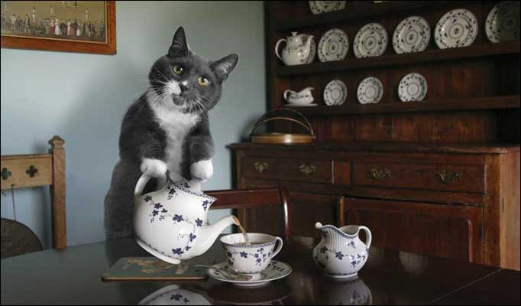
Retrieved from: http://molempire.com/2011/10/02/lolcats-become-house-cats/

- The SII
The SII is a process that helps people learn from experience and give feedback. It is a model that you can use to have students’ assess their own performance, their peer’s performance or your performance.
Write down: Strengths – a strength is an action that produces a desirable outcome or benefit (What is it, How is it a strength and Why does that matter)
Improvement—an action that you take in the future to produce a better result in the future. (What are the issues? What is the new goal and how can it be achieved? What is the plan to achieve the goal?
Insight—Is a new recognition or understanding about something. AHA—What new idea came to you? What is the meaning of the new idea? How can this be applied generally across contexts.
Reference: http://connect-learning-system.wikidot.com/sii
- Muddiest Point
Technique developed by Frederick Mosteller of Harvard in 1989. Asks students to record the thing that is least clear in a course or session.
- Determine what you want feedback on
- Let students know what you are going to do with their responses
- Start next class with summary
Reference: http://www.unl.edu/gradstudies/current/teaching/muddy
- One Minute Paper
A short writing activity in response to an instructor posed question. It can provide the instructor feedback about student learning, metacognition or perception of instruction
Reference: http://oncourseworkshop.com/self-awareness/one-minute-paper/
- Guided/Reflective Journal
A recording of ideas, thoughts and experiences, as well as reflections and insights students have in the learning process. Does not have to be a graded exercise and can include reflection both on learning and teaching. Can be structured or unstructured, but it needs clear guidelines.
Reference: http://ar.cetl.hku.hk/am_rj.htm
- Exam Wrappers
Learning from the test. Usually an exam wrapper asks a student what he/she did to prepare, analyze the questions that they got wrong, identify strategies that they should have employed and then develop a plan for success.
http://www.duq.edu/about/centers-and-institutes/center-for-teaching-excellence/teaching-and-learning/exam-wrappers

Quiz/Surveys
Survey Settings (Graded/Ungraded, Keep Submission Anonymous)
Entering Questions (show how to enter drop downs)
Survey Statistics (export file from ARH 2000)
Bonus: How to give an Extra Credit quiz in Canvas
DO: Practice setting up Likert like question in Canvas
How familiar are you with Tasseography
1. I have never heard of it.
2. I have heard of it, but don't know what it is.
3. I have some idea of what it is, but I am really not sure
4, I know what it is and could explain how to do one
5. I have acted as a tasseographer

Discussion/Journal
Consider a “big picture” in which the class finds relevant examples
- Use the redirect LTI to have the link on the left menu
Set up individual Journals by:
- Under People, set up a group set with as many groups as there are students.
- Auto-assign, then go back and change each group to the name of the student who owns it
- Have students journal here throughout the term or in an adhoc fashion
- As rubric is a good idea, and comments along the way will help. You grade it once at the end of the term.

